Estimating Flooring Materials

Introduction
How do we use mathematic equations, like the formula for area, in real-life situations? Today you will participate in an activity that allows you to choose the flooring for a home and then calculate the cost. Balancing your budget is a key component to success. Most of us have a strict budget and need to choose affordable materials that allow us to live within our means.

When calculating the area of a room, you often have to take into consideration both the feet and inches. When converting to fractions, it is important to remember that feet and inches use the base numbers of 12, not 10, as in decimals. 12” = 1’ | 12’-3”  8’-9”
Therefore: 12’ - 3” = 12 3/12 =  12 ¼ or 12.25  and  8’ - 9” = 8 9/12 =  8 ¾ or 8.75 | Area = Length x Width  A = 12’ - 3” x 8’ - 9”  A = 12.25 x 8.75 = 107.1875 sq. ft.

In this activity you will choose the flooring that best suits your tastes, is the best material for the function of the space, and is the best material to fit your budget. You should also consider sustainability when choosing your resources. Don’t just consider the material itself, but also think about where it comes from, how far it travels, whether it is a renewable resource, etc.

Equipment
- Engineering notebook
- Pencil
- Budget card
- Calculator

Procedure
- Choose a Budget Card. This is the budget that you must stay within when calculating the flooring for your home. This will directly impact the material choices you can make.
- Find the Flooring Materials PowerPoint in the Architectural Basics Folder on Edmodo. Identify the materials that you like and would want in your home. Choose all of the options that appeal to you.
- Use the provided floor plan to complete the first two columns in the Flooring Estimation Worksheet.
- Find the room sizes and record in the column provided.
- Calculate the area of the spaces (A = L X W).
- Choose a material for the specified room. You need to use at least three different flooring materials for the house.
- Record the material and the cost for each square foot.
- Calculate the cost of the flooring material for each specified area or room.
- *Note: When finding square footage, it is important to round up to the nearest whole measurement. You want to overestimate a little, but not so much that you have a lot of leftover materials.
- Calculate the total flooring cost. Are you within your budget? If not, redo with a different material.
- Discuss your flooring choices and why you made them with your classmates.
- Answer the conclusion questions.

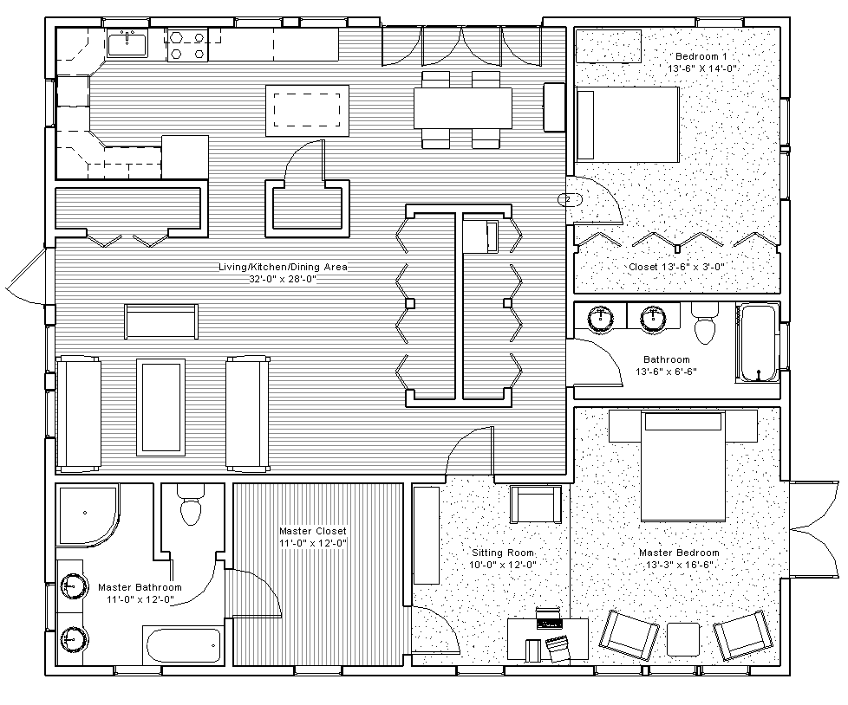

Calculate the flooring cost for your situation. Budget: $3750.00
les | Size of Room | Sq. Ft.  of Room | Material | Cost Per Sq. Ft. | Cost for the Room
Living/Kitchen/Dining Area | 32’ x 28’ | 896’ | Sheet Vynal | $1.00 | $896.00
Master Bathroom | 11’ X 12’ | 132’ | Sheet Vynal | $1.00 | $132.00
Master Closet | 11’ x 12’ | 132’ | Cremic Tiles | $1.58 | $208.56
Sitting Room | 10’ x 12’ | 120’ | Carpet Tiles | $1.40 | $168.00
Master Bedroom | 13.25’ x 16.5’ | 218.625’ | Bamboo | $4.48 | $979.44
Bathroom | 13.5’ x 6.5’ | 87.75’ | Sheet Vynal | $1.00 | $87.75
Bedroom 1 | 13.5’ x 14’ | 189’ | Cork | $4.12 | $778.68
Closet in Bedroom 1 | 13.5’ x 3’ | 40.5’ | Sheet Vynal | $1.00 | $40.50
You need to use at least three different flooring materials in the home.
Total Flooring Cost for Home: $3,290.93

Conclusion
- What details did you consider when you were choosing your flooring materials?
What they looked like and the price

- How did your budget impact your material decisions?
Some were too expensive to buy

- Why is it important to make sure your calculations are accurate?
If you miss calculate you may not have enough or you may have way too much

- If you need 107.1875 sq. ft. of flooring materials, should you buy 107 sq. ft. or 108 sq. ft.? Why?
108 because if you get 107 you won’t have enough for the extra .1875 flooring and it won’t look good

- What can you do with leftover flooring supplies?
Save it incase anything rips

